**Model Name:** Meta MMS Urdu TTS (facebook/mms-tts-urd-script_arabic & ..._devanagari)

**Link:** <https://huggingface.co/facebook/mms-tts-urd-script_arabic>

**Input 1:**

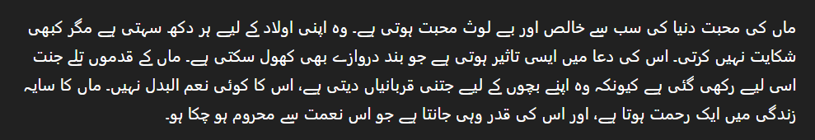

**Time Taken:** 107 seconds

**Accuracy:** Good

**Input 2:** 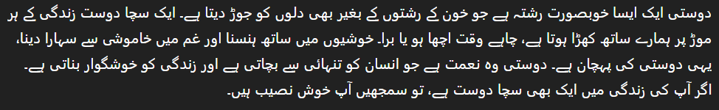

**Time Taken:** 118 seconds

**Accuracy:** Very Good